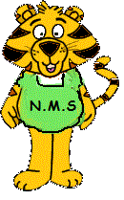
Grade 1 October Newsletter
Mlle Patterson
We will be working on the following outcomes this month:
Literacy:
The themes we will be working on this month are “My Family” and “Animals”
Oral:
We will continue to review the previously learned sentence structures while also adding in sentence structures and vocabulary involving our families, pets and favorite animals.

Reading:
We will continue learning five new sights words a week. We will also review the previous words daily. We continue to work on sounds while reviewing our previously learned sounds as well. We will be reading many books about our themes, all in the form of read-aloud and shared reading.

Writing:
Writing is always modelled and based on our themes. This month, students will complete roughly 4-5 writing pieces, most consisting of one to two sentences. We will also be practicing our letters and theme words on white boards.

Math:
Represent Numbers to 15 (Count to 20)

Students will:
→Count forward by 1s from 0 to 20 and between any two given numbers
→Show understanding of counting sets by:
• showing that any set has only one count
• using the ‘counting on’ strategy
→Represent and describe numbers to 15 in different ways (materials, numerals, pictures, words).
→Compare sets containing up to 15 elements to (using ‘more’, ‘fewer’, ‘the same’)
→Demonstrate, using pictures and materials, how a given number can be represented by a variety of equal groups with and without singles.
→Identify the number, up to 15, that is one more, one less than a given number.

Patterns

Students will:
→ Demonstrate an understanding of repeating patterns (two to four elements) by: describing, reproducing, extending and creating patterns using manipulatives, diagrams, sounds and actions.

→Translate repeating patterns from one representation to another.

You and Your World: safety

As it is going to be safe schools week, we will discuss fire drills, lockdowns, and evacuations.
We will also continue learning about “expected behaviour” at school.

Upcoming:
Mon. Oct. 8th – Thanksgiving (No School)

October 15th- Hot Lunch forms are due back

Mon. Oct.15-19th – Safe Schools Week

Thursday October 17th- Fire station fieldtrip

Friday Oct. 18th- Picture Retakes ☺

Tuesday Oct 23d- Milk forms and money are due back

Wed. Oct. 24th – Halloween Howl 5:30pm-7pm

, s

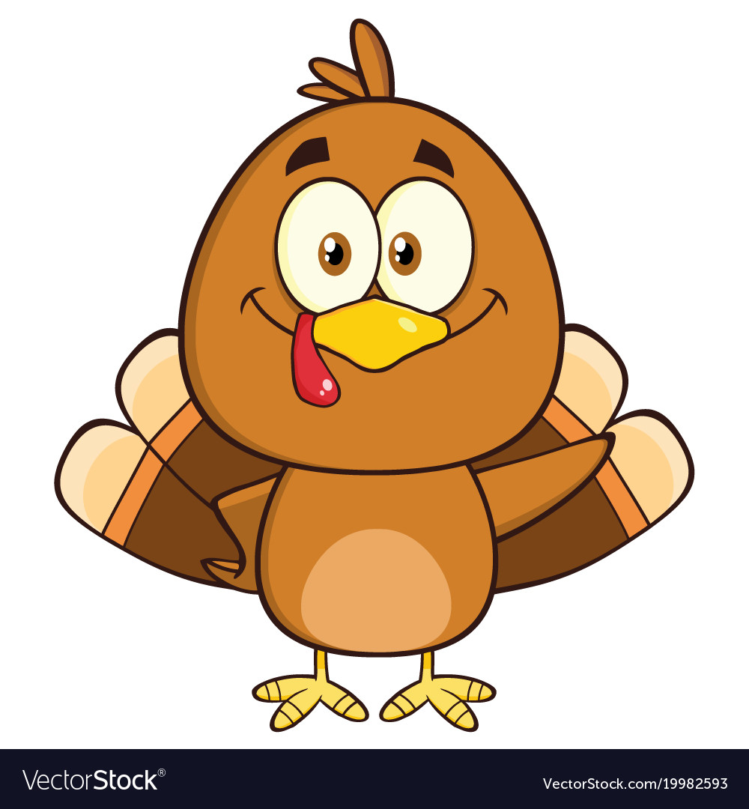October Calendar – Mlle Patterson
NOTES:  Please be sure to look in your child’s Communication Bag daily for any notes, reminders or forms that may be going home.  For Safe Schools Week, October 15th-19th, your child will learn about fire safety, and practice fire drills, lock downs and evacuations.  Please be mindful of our healthy schools policy; do not send in treats for Halloween. | Monday | Tuesday | Wednesday | Thursday | Friday
 | 1 | 2 | 3 | 4 | 5
 | 8  Happy Thanksgiving!!!  (no school) | 9 | 10 | 11 | 12
 | 15  Hot Lunch money and forms are due  Safe Schools Week | 16 | 17  Fire station fieldtrip | 18  Picture Retakes | 19
 | 22 | 23  Milk forms and money are due   | 24  N.M.S Halloween  Howl (5:30-7pm) | 25 | 26
 | 29 | 30 | 31  Black and Orange Day!

